Pair Project Proposal

Course: Data Science and Data Visualization
Course ID: CISC7204
Member A: Zeng Zhaorong MC659221
Member B: Zhang Haoyin MC654642

Project Topic Name

Exploring heart-disease risk factors from clinical data with synthetic-dataset comparison

Precise Research Question

Using real-world cardiovascular screening patient data from multiple European and American clinical centres (heart.csv), how do clinical indicators including cholesterol, resting blood pressure, fasting blood sugar relate to heart disease presence, and do these associations differ by sex and age groups? For reference, we also check whether diabetes and hypertension show similar disease-correlation patterns in an alternative synthetic heart disease dataset (heart_disease.csv).
dataset links:
https://www.kaggle.com/datasets/oktayrdeki/heart-disease
https://www.kaggle.com/datasets/johnsmith88/heart-disease-dataset

Project Purpose

Outcomes
We aim to identify how common clinical measurements connect with heart disease risk, and see if these links change across different sexes and age groups. We will produce a Jupyter notebook with clean code, statistical tables and multi-layered visualisations to present our findings. A simple comparison with a secondary synthetic dataset will also be included for reference.

Skills
This project helps us practice data cleaning and exploratory analysis in Python. We will learn to build meaningful visualisations using like Matplotlib and Seaborn, and to interpret grouped statistics carefully. We also get practice separating main analysis from supporting reference data when working with multiple datasets.

Knowledge
We will learn how heart disease risk factors such as cholesterol and blood pressure work in real clinical screening data. We will also understand how sample characteristics like age and sex can change the pattern of these risk associations. In addition, we will see the difference between real clinical data and synthetic simulated datasets.

Project Tasks

We first load and clean the primary dataset ‘heart.csv’. we carry out exploratory statistical analysis. We calculate descriptive statistics for continuous clinical measurements grouped by heart disease status, and repeat this analysis stratified by sex. We split cholesterol and resting blood pressure into high and low groups using median values, then compare heart disease rates between these groups. We also explore how risk factors perform separately within our two age brackets.

For visualisation, we build three plots with Matplotlib and Seaborn. The first plot is a boxplot combined with a stripplot showing cholesterol distribution by heart disease status and sex. The second is a pair of countplots to show the distribution of chest pain types and fasting blood sugar across different sexes. The third visualisation is a correlation heatmap of all continuous clinical variables.

After finishing the main analysis on ‘heart.csv’, we move to the secondary synthetic dataset ‘heart_disease.csv’. We only keep shared variables for simple comparison. We clean the subset of data, then make one stacked bar chart to show heart disease proportions for diabetes and hypertension groups. We compare trends from this chart against patterns found in the primary dataset.

Finally, we organise all code, tables and figures in a complete Jupyter notebook and prepare our project proposal.

Visualisation image reference
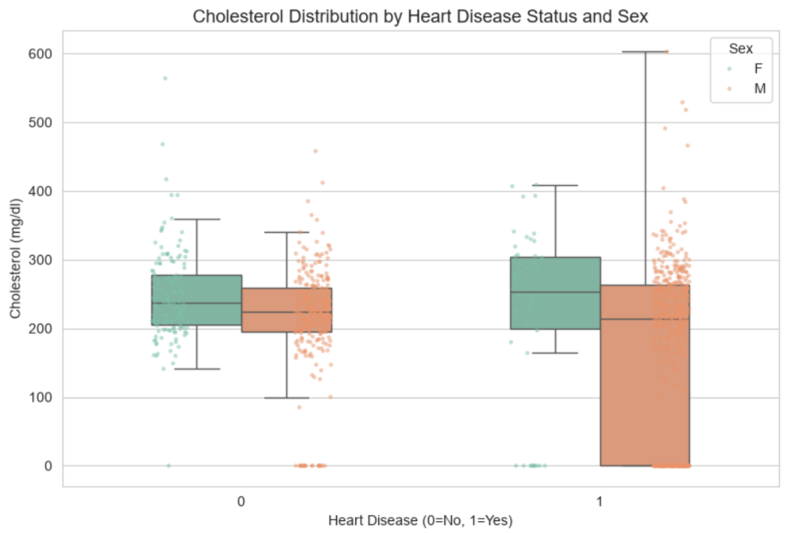
Figure 1 Cholesterol Distribution by Heart Disease Status and Sex (boxplot with stripplot overlay)

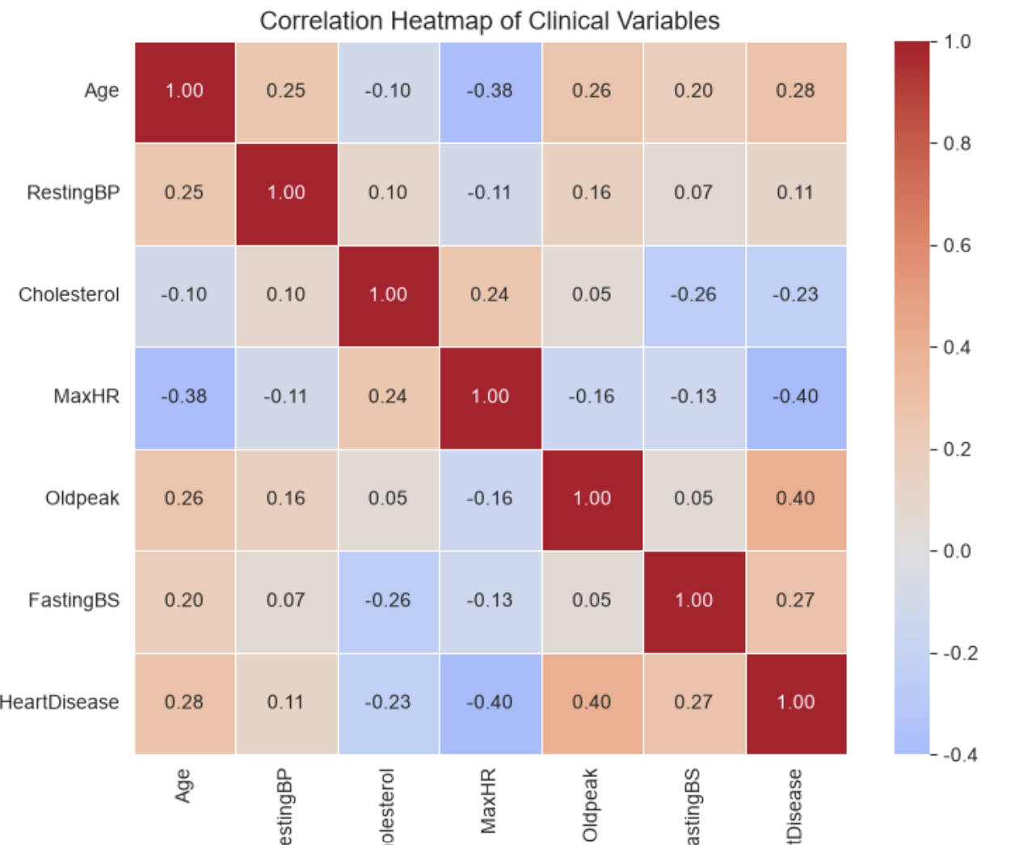
Figure 2 Correlation Heatmap of Clinical Variables

The combined box and stripplot lets us directly see how cholesterol levels differ between patients with and without heart disease, and we can observe whether this pattern changes for men and women. The correlation heatmap quickly shows the strength of linear links between clinical measurements and heart disease. Together these two plots show how risk factors relate to heart disease and if these relationships vary by sex or age.

Project Criteria for Success

The project delivers a complete, run-nable Jupyter notebook with well-commented Python code for both datasets. All tables and visualisations should have clear labels and correctly reflect analysis outputs.
The core findings from ‘heart.csv’ must directly address our research question about clinical risk factors, sex and age group differences. Results from the secondary synthetic dataset are presented only for reference, with its limitations clearly stated.

Referring to Ken Jee’s 7-part data science workflow, our pair project has fully finished Part1 Project Planning, Part2 Data Collection, Part3 Data Cleaning and Part4 Exploratory Data Analysis. We do not carry out model building or model deployment (Part5 and Part6), as our task focuses on exploratory analysis rather than predictive modelling. We also complete Part7 Documenting Your Work by writing the project proposal and commenting our Jupyter notebook code. Most of our finished work, including research questions, dataset plans and analysis tasks, has been summarised and refined into this revised pair project proposal.

Project Collaboration

1. Expected division of work among team members:
Member A takes charge of processing and analysing the primary dataset ‘heart.csv’. This includes completing data pre-processing, generating descriptive statistics and all visualisations for the main analysis.
Member B handles the secondary dataset ‘heart_disease.csv’. Member B is also responsible for drafting the full proposal text, double-checking consistency between analysis outputs and research questions, and documenting dataset limitations.

2. Ground rules for group-based project work:
Both members review all deliverables before submission. Any major changes to analysis logic or proposal content need discussion and mutual agreement. We communicate regularly to track progress and resolve misunderstandings early.

3. Group roles:
(1) Project coordinator: Member A (oversees overall project timeline, schedules check-ins)
(2) Project scribe: Member B (writes and revises proposal documents, records group discussions)
(3) Project progress tracker: Member A (monitors task completion status, reminds of deadlines)
(4) Project liaison: Member B (handles cross-check between code output and written proposal)

